**Architectural Design: DesignPad**

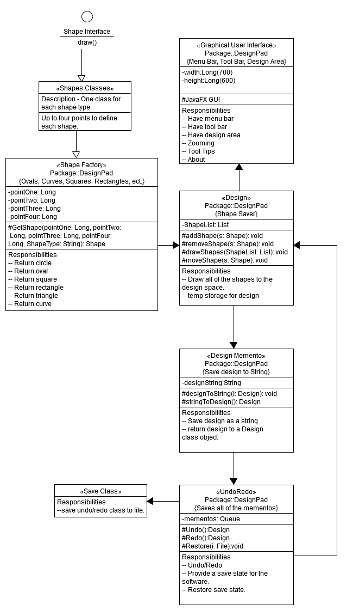

**Component-Level Design: DesignPad**

**Shapes Interface -** This interface contains the draw() function. Each shape must be able to be drawn to the screen. That is the basic function of a shape. It is the implementation of this interface that allows shapes to be drawn to the Design Pad.

**Shapes Themselves** – Uses the pre-defined shapes library to create old and new shapes. Rectangles, Squares, Ovals, Circles, Triangles and Curves are all examples of classes of this type. These shapes are pre-defined in the JavaFX library. These classes take up to four variables. These variables are points with x and y coordinates. For instance, a rectangle requires two points for definition where a curve requires four. The shape of course includes a draw function that can draw the shape to the screen.

**Shape Factory** – The Shape factory can return any shape to the Design class as that shape is drawn to the screen. The shape name if fed in through a string and the appropriate object is returned to the Design class.

**Design Class** – The design class has a list that is a repository for the shapes that are being drawn to the screen. Multiple shapes are drawn simultaneously hence the drawShapes() function that draws all of the current shapes to the screen. The Graphical User Interface(GUI) simply uses the drawShapes() function to draw the shapes. The drawShapes() function calls the draw() function from each shape in the shapes list. AddShape() function takes shapes drawn in the GUI and adds them to the list.

**GUI Class** – This is a JavaFX application so, the GUI is found in the same class as main. A menu bar is found here with drop down menus. Each button in the dropdown menu hooks up to a function in the software.

* File
  + New- Creates a new Design instance.
  + Open- Restores a saved file from UndoRedo class
  + Save- Uses the save class to save a file from the UndoRedo class
  + Export- Not yet sure how to export file to jpeg
* Edit
* Undo: Restores a previous Memento
* Redo: Restores the next Memento
* Copy: Put the selected shape into the clipboard.
* Cut: Puts the selected shape into the clipboard and deletes the selection from the Design class.
* Paste: Pastes the content of the clipboard to the screen.
  + View
* Zoom in: Maximum 150% - Strictly GUI function
* Zoom out: Minimum 50% - Strictly GUI function
* 50% - Strictly GUI function
* 75% - Strictly GUI function
* 100% - Strictly GUI function
* 150% - Strictly GUI function
  + Help
* About – GUI produces a message box with a blurb about the program
* Tool Tips – The GUI produces another message box with tips on how to use the program.
  + Buttons
* Rectangle – Takes in mouse information to draw a rectangle to the screen, get it from the shapeFactory and add it to the Design class list of Shapes.
* Square – Takes in mouse information to draw a square to the screen, get it from the shapeFactory and add it to the Design class list of Shapes.
* Oval – Takes in mouse information to draw an oval to the screen, get it from the shapeFactory and add it to the Design class list of Shapes.
* Circle – Takes in mouse information to draw a circle to the screen, , get it from the shapeFactory and add it to the Design class list of Shapes.
* Triangle – Takes in mouse information to draw a triangle to the screen, get it from the shapeFactory and add it to the Design class list of Shapes.
* Curve – Takes in mouse information to draw a curve to the screen, get it from the shapeFactory and add it to the Design class list of Shapes.

**Design Memento** – Turns the Design class list into a string that hold all of the information in the list. It saves the string in a string object. The string can be restored to an Design object via the stringToDesign() function.

**UndoRedo** – The UndoRedo class undoes and redoes steps of the design process. Each step a memento is added to a queue of mementos in this class. To undo one earlier memento in the string is restored and becomes the current Design list. To redo one later memento in the queue is restored to the current Design object. This is also the object that gets saved to file.

**Save** – Saves the UndoRedo queue to file in the form of a delimited string. Saving the queue saves the current design, as well as, the previous designs leading up to the current design. Saved files can be restored to the current UndoRedo object which in turn restores the first memento in the queue to the current Design object.

**Export** – Using the JavaFX snapshot feature the program will be able to Export the draw pane to jpeg format. This code is included in the GUI

**Design Patterns Used: DesignPad**

* Factory design pattern - This pattern is used to fetch the shapes from the shape classes and instantiate them in the client class.
* Memento pattern. This pattern is used primarily in the UndoRedo class. It is useful for storing snapshots of the design and inserting them into an Undo/Redo queue.
* Façade - The last design pattern being used here will be with the Graphical User Interface(GUI). This design pattern is called a Façade and it is self-explanatory. The GUI hides behind it keeping the main function clear for the other important implementation.

**Reusable Components: DesignPad**

All of the Shape classes are reusable classes. The list of shape classes includes the Rectangle Class, Square Class, Oval Class, Circle Class, Triangle Class and Curves Class. These objects are produces through a ShapeFactory which there will only be one of. The shapes are stored in a list in the Design class. Many instances of each shape type can be present in that list. The shapes all together make up the design. Through the Design class all of the shapes are displayed simultaneously.

Another reusable class includes the DesignMemento class. Many DesignMementos are used in the UndoRedo class. In this class they are stored in a queue enabling the Undo and Redo functions of the software. If the design is to be saved it is the information stored inside the queue of mementos that must be put into a file format.

**UI Level Design: DesignPad**

The UI consists of a menu bar at the top a tool bar below that and a design area below that. The menus in the menu bar are drop down menus with the typical selection options. File has New, Open, Save and Export. Edit has Undo, Redo, Copy, Cut and Paste. View has Zoom In, Zoom Out, 50%, 75%, 100% and 150%. The Help menu has About and Tool Tips. The rest of the UI consists of a design area with in a scroll box. This is the part of the screen where the design is created.

